**ATTACHMENT 2- Aerial Photo and WLEP 2009 Zoning Map**

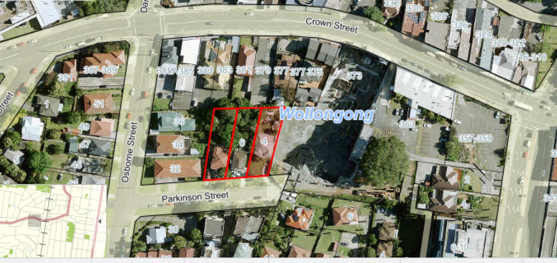

***Figure 1: Aerial Photo***

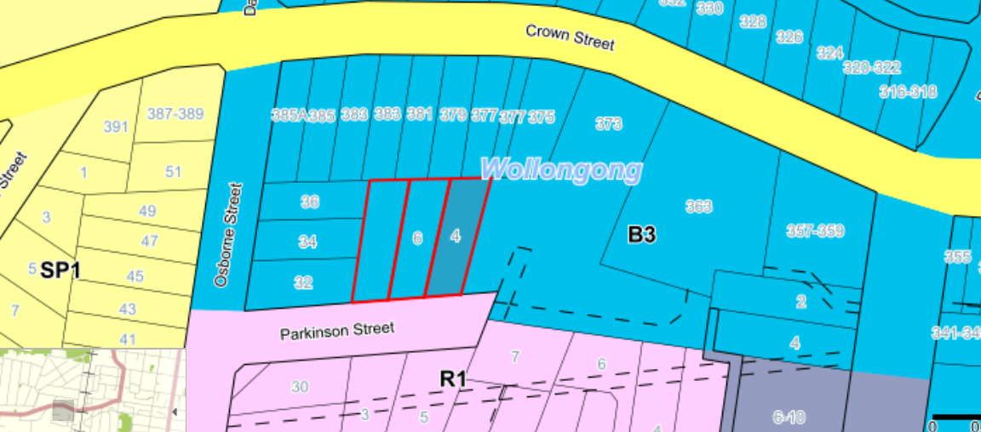

***Figure 2: WLEP 2009 Zoning Map***